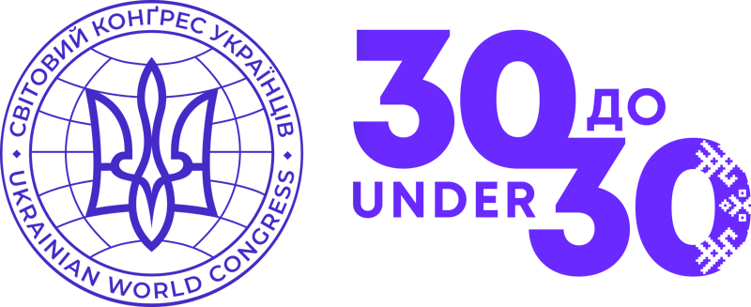

**Nomination Form**

**UWC 30 Under 30 Initiative**

*The project aims to introduce Ukraine and the world to the brilliant and talented Ukrainian youth leaders in the diaspora who were born after Ukraine declared Independence in 1991. On August 19, the names of 30 young diaspora Ukrainians who are shaping the present and future of their communities will be announced!*

Participants in the UWC 30 to 30 initiative are Ukrainian youth in the diaspora who:

* are of Ukrainian origin, are citizens of Ukraine and/or other countries, and have permanently resided outside Ukraine for at least two years,
* will be under the age of 30 as of August 23, 2021 (were born after August 24, 1991),
* are active in their local Ukrainian communities and proactively promote a positive image of Ukraine, the Ukrainian community, and/or Ukrainian people.

*Candidates from Ukraine are not eligible.*

The shortlist of 30 young leaders will be formed by an expert committee headed by the UWC President. Initiative, creativity, teamwork and leadership skills, volunteering in the Ukrainian community, as well as achievements in their country of residence will be crucial in the formation of the UWC 30 to 30 List.

Candidates for the list can be nominated by member organizations of the Ukrainian World Congress and Ukrainian institutions abroad by filling out this form and sending it to [30under30@ukrainianworldcongress.org](mailto:30under30@ukrainianworldcongress.org) *by July 7, 2021*. Individuals who are not members of these organizations / institutions can submit an application for consideration by the UWC Regional Vice Presidents using the electronic form on the initiative's official website: [30under30.ukrainianworldcongress.org](http://30under30.ukrainianworldcongress.org) *by 7 July 2021*.

By submitting this form, you acknowledge that you have read, understood and agree to the UWC Privacy Policy set out at: [www.ukrainianworldcongress.org/privacy-policy/](http://www.ukrainianworldcongress.org/privacy-policy/)

*Name of your Ukrainian diaspora organization / institution*

|  |
| --- |
|  |

*Nominee information*

|  |  |
| --- | --- |
| First Name |  |
| Last Name |  |
| Age |  |
| Nominee’s contact email |  |
| Nominee’s contact telephone |  |
| Link(s) to social media profile(s) |  |
| Period of residence in the diaspora |  |
| Period of activity in Ukrainian public life |  |
| Region of residence | * North America * South America * Western Europe * Central and Eastern Europe * Russian Federation * Australia, Oceania, Asia, and Africa |

|  |  |
| --- | --- |
| Country of residence | City of residence |
|  |  |

|  |  |
| --- | --- |
| Is the nominee a member of Ukrainian community organizations or institutions? | |
| * Yes | * No |
| Names of organizations/institutions the nominee is a member of |
|  |

|  |  |
| --- | --- |
| Description of the nominee's achievements in Ukrainian community life  (please highlight how they demonstrated initiative, creativity, teamwork and leadership skills, volunteer work in the Ukrainian community, efficiency or other achievements in the country of residence) (*300 words limit)* | |
|  | |
| References to projects, events, or activities involving the nominee  (links to social media pages or websites) | |
|  | |
| Have you informed the nominee of your intention to nominate them? | |
| * Yes | * No |

*Signature of the authorized representative of the organization / institution*

*nominating the candidate*

|  |  |
| --- | --- |
| First Name |  |
| Last Name |  |
| Email |  |
| Link(s) to social media profile(s) |  |

*Initiator of the nomination, if different*

|  |  |
| --- | --- |
| First Name |  |
| Last Name |  |
| Email |  |
| Link(s) to social media profile(s) |  |

Full Name: ______________________________________

Signature: _______________________________________

Дата:

|  |
| --- |
|  |